**Formation of spur gear by using involute gear cutter on horizontal milling machine.**

**Apparatus:**

Milling Machine, Aluminum rod, involute gear cutter.

**Figure:**

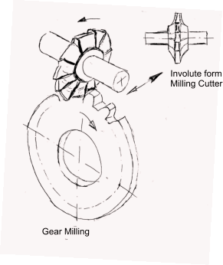

**Theory**

**Gear**

A gear is a kind of machine element in which teeth are cut around cylindrical or cone shaped surfaces with equal spacing. By meshing a pair of these elements, they are used to transmit rotations and forces from the driving shaft to the driven shaft. Gears can be classified by shape as involute, cycloidal and trochoidal gears.

**Spur Gear**

Gears having cylindrical pitch surfaces are called cylindrical gears. Spur gears belong to the parallel shaft gear group and are cylindrical gears with a tooth line which is straight and parallel to the shaft.

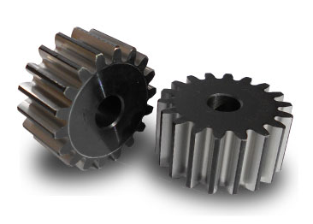

**Helical Gear**

Helical gears are used with parallel shafts similar to spur gears and are cylindrical gears with winding tooth lines. They have better teeth meshing than spur gears and have superior quietness and can transmit higher loads, making them suitable for high speed applications.



**Gear Rack**

Same sized and shaped teeth cut at equal distances along a flat surface or a straight rod is called a gear rack. A gear rack is a cylindrical gear with the radius of the pitch cylinder being infinite

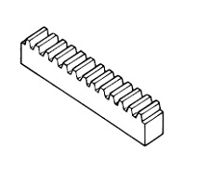

**Bevel Gear**

Bevel gears h`a cone shaped appearance and are used to transmit force between two shafts which intersect at one point (intersecting shafts). A bevel gear has a cone as its pitch surface and its teeth are cut along the cone.

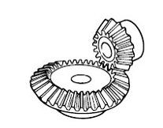

**Gear Terminologies**

* **Pitch surface** : The surface of the imaginary rolling cylinder (cone, etc.) that the toothed gear may be considered to replace.
* **Pitch circle**: A right section of the pitch surface.
* **Addendum circle**: A circle bounding the ends of the teeth, in a right section of the gear.
* **Root (or dedendum) circle**: The circle bounding the spaces between the teeth, in a right section of the gear.
* **Addendum**: The radial distance between the pitch circle and the addendum circle.
* **Dedendum**: The radial distance between the pitch circle and the root circle.
* **Clearance**: The difference between the dedendum of one gear and the addendum of the mating gear.
* **Face of a tooth**: That part of the tooth surface lying outside the pitch surface.
* **Flank of a tooth**: The part of the tooth surface lying inside the pitch surface.
* **Circular thickness** (also called the **tooth thickness**) : The thickness of the tooth measured on the pitch circle. It is the length of an arc and not the length of a straight line.
* **Tooth space**: The distance between adjacent teeth measured on the pitch circle.
* **Backlash**: The difference between the circle thickness of one gear and the tooth space of the mating gear.

Backlash =Space width – Tooth thickness

* **Circular pitch** p: The width of a tooth and a space, measured on the pitch circle.
* **Diametral pitch** P: The number of teeth of a gear per inch of its pitch diameter. A toothed gear must have an integral number of teeth. The *circular pitch*, therefore, equals the pitch circumference divided by the number of teeth. The *diametral pitch* is, by definition, the number of teeth divided by the *pitch diameter*.
* **Module** m: Pitch diameter divided by number of teeth. The pitch diameter is usually specified in inches or millimeters; in the former case the module is the inverse of diametral pitch.
* **Fillet**: The small radius that connects the profile of a tooth to the root circle.
* **Pinion**: The smaller of any pair of mating gears. The larger of the pair is called simply the gear.
* **Velocity ratio**: The ratio of the number of revolutions of the driving (or input) gear to the number of revolutions of the driven (or output) gear, in a unit of time.
* **Pitch point**: The point of tangency of the pitch circles of a pair of mating gears.
* **Common tangent**: The line tangent to the pitch circle at the pitch point.
* **Base circle** : An imaginary circle used in involute gearing to generate the involutes that form the tooth profiles.

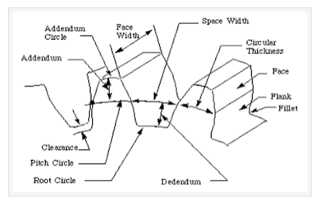

**Procedure**

* Measure diameter of rod on which gear are to be form and divide it with module number which give teeth number
* Select proper indexing plate and place rod in indexing head
* Place involute gear cutter in arbor
* Give proper feed in longitudinal direction and start to form gear.

**Observations and calculations**

|  |  |  |  |  |  |
| --- | --- | --- | --- | --- | --- |
| Sr. No | Diameter of Rod | Module No. | No. of teeth  N=D\m | No. of turns of indexing plate  T=40\N | Indexing Plate No. |
| D | m |  | T |
| 1. |  |  |  |  |  |
| 2. |  |  |  |  |  |

**Questions**

Write about the different types of gears?

_________________________________________________________________________________________________________________________________________________________________________________________________________________________________

Which types of method used for formation of gears?

_______________________________________________________________________________________________________________________________________________________________________________________________

How broaching machines work?

________________________________________________________________________________________________________________________________________________________________________________________________

What is pressure angle in involute gear cutter?

________________________________________________________________________________________________________________________________________________________________________________________________________________________________

**Comments:**

**________________________________________________________________________________________________________________________________________________________________________________________________**